**Business Requirements Case Study - Group**

Case study: Requirement Analysis and Solution Design - (18, August, 2023) 40%:

**Team Blackhat:**

Taylor Wagstaff

Jeffrey Sievers

Zane Walden

**Task 1 Current Business Requirements: (Taylor Wagstaff)**

Questions for Tongariro Cinemas Limited  
  
**-What are the key challenges faced by Tongariro Cinemas Limited in the current manual system?**   
Phone calls & booking system, time limitation

Solution is to make booking system

**-What do you expect from us?**   
provide solution, form of automation, should be responsive, media queries?

**-What is the expected timeline for this project?**   
9 weeks

**-What is the projected budget for the system upgrade?**   
30k

**-How many team member roles do you envision for this project?**   
part time or full time work

**-How many users (employees and customers) are expected to interact with the new system?**   
4, could double? Efficient/ real-time

**-Are there any specific areas where you want to see immediate improvements?**   
more customer oriented, wants to attract customer, channel of communication with customer, create some sort of poles from customer.

**-What are the expectations in terms of return on investment from this system upgrade?**   
have u use frame work react etc. response time should be minimal

**-Are there any specific legal or regulatory requirements to consider while upgrading the system?**   
more customers, more money

**-What is the expected impact on customer experience post the system upgrade?**   
  
**-What functionality would you like to see in the new system?**

**-Would you want the new system to integrate with your Café operations managed by Qullean Catering Company?**   
not yet, just have resovations

**-Do you want an online booking feature for the new system?**   
yea

**-What kind of payment methods do you wish to support?**   
visa, stripe

**-Would you want the system to facilitate any marketing or promotional activities, like sending movie updates or discounts to customers?**   
yea that’s great. Promotional vids.

**-What are the security requirements for the new system?**   
the most important , dealing with customer info  
  
**-What sort of Design Scheme do you imagine for this website?**

Catchy colorful Userfriendly

**-Is there anything you would like to share about the project?**

Asked everything all good. Start on the req focus on the customers.

-Would you like any KPIs or analytics to track users on your website? And for what use would you want to use this data?

Yes we want analytics to track on the website, such as page views etc.

**Task 2 Current Business processes:**

· identified and included a short description

In response to the questions, Tongariro Cinemas Limited desires a website which serves as an upgrade to their pre-existing system. Currently they are using a manual booking system, and so to improve efficiency and the responsiveness of the customer, Tongariro has asked us to implement a solution. The company wants the website to be user friendly, colorful and ultimately attractive to the customer, the website should also cater to range of device sizes. The current manual booking system has extreme limitations, since it relies on a manual phone system to operate. One of the required solutions asked by Tongariro Cinemas is to transform this manual process into a digitized format so that customers are able to book tickets online and manage real-time bookings. An important feature for the business is support for an online payment method using credit card information like visa, it is also important for this information, as well user details, to be secure from possible online threats. It is important that the system maintains the highest levels of security, given the handling of sensitive customer information. The cinema hopes that this new ordering system will help attract new customers due to accessing a larger audience online through improved channels of communication. Through tracking customers online, the business should be able to monitor its traffic, with options to include customer polls. The company has expressed interest in incorporating KPIs and analytics to track website users and monitor page views for better understanding of user behavior and performance evaluation. Tongariro Cinemas would like a range of marketing possibilities, such as sending movie updates or discounts on tickets. The integration of the Cafe is not required to be implemented into the website and is considered separate. The budget for this system upgrade is $30,000 and the project is expected to be completed within a 9-week timeline. The project team size hasn't been specified. There is no mention of any specific legal or regulatory framework at this stage, however, compliance with data is assumed.

### **Business Process Model**

#### 1. Film Scheduling and Showing

* Tongariro Cinemas has four small theatres within its complex in Wellington.
* Each of these cinemas runs three times a day, showcasing four different films — two classic movies and two new releases.

#### 2. Governance Structure

* The cinema's management structure involves a Manager who reports directly to the board.
* The board is comprised of the Chairman and Secretary. They are in paid roles, with four other members who volunteer their time.
* They hold monthly meetings to discuss how the cinema progresses, their budgets, income, and other key topics.

#### 3. Administrative Operations

* There is one full-time Admin/Secretary/Finance Person who handles tasks such as bookings, cancellations, and income reconciliations.
* This role also involves creating monthly board reports.
* The Manager and the Admin/Secretary/Finance Person share one computer for reporting, using the Xero accounting software package and email for communications.

#### 4. Sales and Transactions

* Currently all transactions are manually conducted, with the exception of finances and Eftpos Transactions.
* The cinema will implement on their website an ordering system to take booking from customers, a payment system will be implemented.

#### 5. Café Operations

* A café within the cinema complex is operated by Qullean Catering Company under lease.

#### 6. Marketing and Outreach

* The cinema wants an online presence, possibly social media engagement and marketing promotions.
* The company acknowledges the need to increase their online visibility and possibly their social media presence in order to attract more moviegoers.

#### 7. System Operations

* The company recognizes the need to upgrade their existing system to improve efficiency and draw in more patrons.
* At present, the system heavily relies on manual operations, which the company seeks to digitize to a certain extent.

#### Future Project

* A project team is tasked to explore the client's needs further and devise a solution to meet these needs.
* This includes automating the booking system, enhancing the online presence, and potentially increasing the engagement on social media.

**Task 3 Context Diagram:**

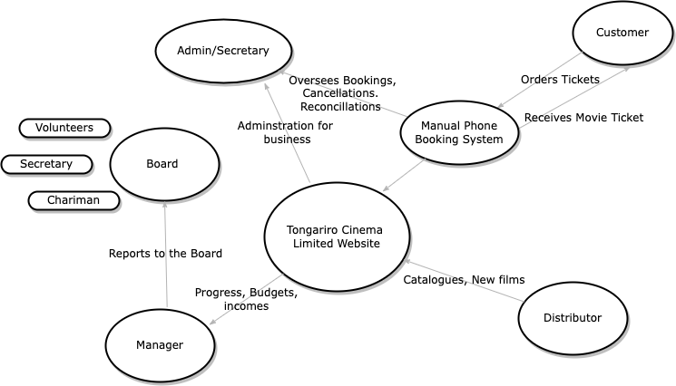

· shows external entities and interactions

**Task 4 Activity sequence diagram:**

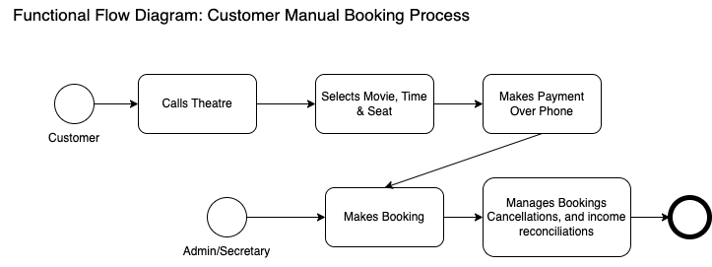

describes one key business process

**Task 5 Activity sequence diagram**

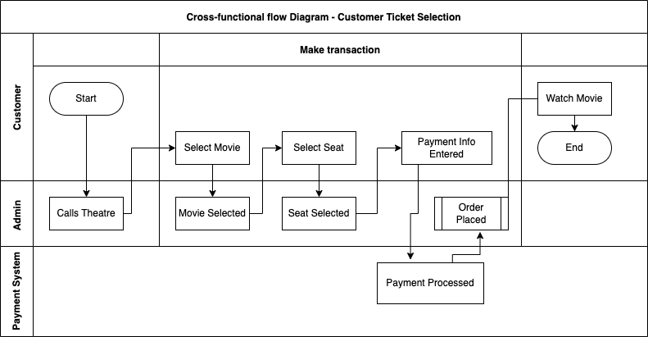

· uses correct notation (BPMN)

**Task 6 Stakeholder list is comprehensive:**

**Clients and customers** - recipients of the outcomes of the Cinema, ordering of tickets.

**Movie providers** - provide resources and support for movies showing

**Admin/Secretary/Finance Person** - who handles tasks such as bookings, cancellations, and income reconciliations.

**Theatre Staff** – Oversees general day-to-day operations, and handles bookings, cancellations, and income reconciliations, as well as taking customers to seats.

**Manager** – Oversees general business and reports to the board.

**Board** – Finacial beneficiaries of the business, makes executive decisions. Made up of a Chairman, Secretary and Volunteers.

**Software Developers** – builds and maintains web services, as well as updates to digital systems.

**Café Staff** - café within the cinema complex is operated by Qullean Catering Company and is responsible for the café.

**Marketing Team** – Possible marketing team for potential marketing campaigns such as social media.

**Task 7 List of business needs / business requirements:**

-Tongariro wants a website that is to be user friendly, colorful and ultimately attractive to the customer, the website should also cater to range of device sizes.

-Transform their current manual booking process into a digitized format so that customers are able to book tickets online and manage real-time bookings.

-Support for an online payment method using credit card information like visa, it is also important for this information, as well user details, to be secure from possible online threats.

-It is important that the system maintains the highest levels of security, given the handling of sensitive customer information.

-The cinema hopes that this new ordering system will help attract new customers due to accessing a larger audience online through improved channels of communication.

-The business should be able to monitor its traffic, with options to include customer polls.

-The company has expressed interest in incorporating KPIs and analytics to track website users and monitor page views for better understanding of user behavior and performance evaluation.

-Tongariro Cinemas would like a range of marketing possibilities, such as sending movie updates or discounts on tickets.

-The budget for this system upgrade is $30,000 and the project is expected to be completed within a 9-week timeline.

-The project team size hasn't been specified.

-There is no mention of any specific legal or regulatory framework at this stage, however, compliance with data is assumed.

-Business need regular support for website maintenance.

**Task 8 Scope of project:**

· first iteration

For Tongariro Cinema, the initial scope and core business process is to be able to “books seats online.” This is because it will make the most difference to the core business. This will bring much-needed profit and value to the organization and will be our ‘Minimal Viable Product.’ After this is achieved, further website styling, login/register for users, promotions for marketing, complex showtimes and seat selection tools, KPIs to track users and more. The scope of this project will follow an Agile approach of iterative development process, producing short stints on a range of functionalities, from most important to the business to the least. As a team, we will be focused on small sets of functionalities, based on the requirements of the business, through coding, testing and regular deployments.

What will not be delivered is one large platform such as a website for a large movie theatre, rather, a small theatre website capable of at least a booking system. Based on the budget, an integrated third-party payment system should be used to save costs and possibly a content management system to manage and handle customer data. A framework will be used as React to provide a responsive website, rather than complex vanilla JavaScript to save time and costs.

**2. Define Future State of Business Case (Jeffrey)**

**Task 1 Context Diagram:**

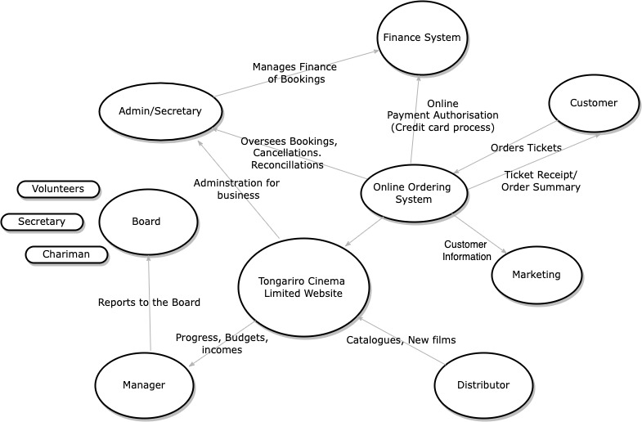

· shows external entities and interactions

**Task 2 Future Business Processes:**

The future Business Processes will be different from the previous manual system. Since the client requires an online system. So, the first future business process is Online Booking System. The shift from a manual phone system to a digital format will allow customers to select movies, times and seats online. These future business processes should improve profitability and efficiency to large online audiences. Part of this future business process is the introduction of an online payment system, systems like Visa or integrations such as Stripe or Shopify. Another future business process is the integration of Data security and encryption, especially when handling customer data. This process will require support and recommendations from data security experts and the appropriate software to handle security, especially through the website. Basic data security will require, at least, sanitization of inputs to handle data forms of payment information, information on orders and customer details. Another process is user analytics and KPIs Tracking, this process will require a staff member to look over these reports and make recommendations to the marketing team about potential promotions. Other future processes is payment processing and billing, since this will be an online payment system, automating what was previously manual, this process will require some level of oversight to make sure it is working smoothly. Prices, movies, times and details should be correct. A customer support staff might be a future process, since people may find It difficult to order tickets online, since the system is transferring to an online system and would need to adjust accordingly. Other future business processes could include Platform Development and Maintenance to regularly update the online system and make sure there are no bugs.

· identified and include short description

**Task 3 Activity sequence diagram:**

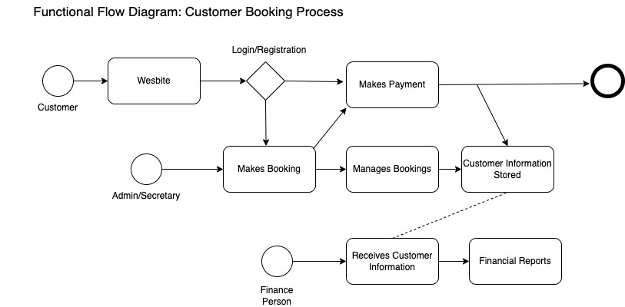

describes one business process within the project scope

**Task 4 Activity sequence diagram:**

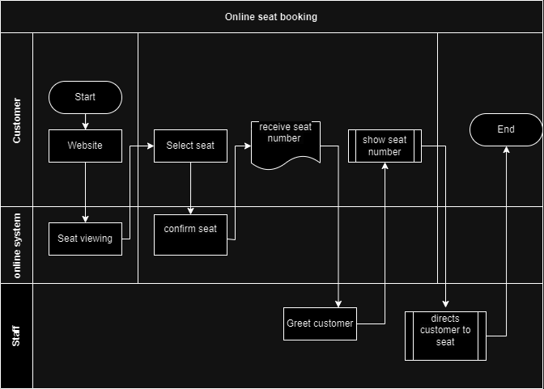

· uses correct notation (BPMN)

**3. Define business solution:**

**Task 1**

**Option One: Basic Online System Solution**

The basic online system uses a striped down approach, only using basic html, css and Javascript. It will have a rudimentary online booking system, of movie, time with no seat selection (customers will seat themselves). An online basic payment system is recommended, with a third-party option or integration with visa. This option will have low maintenance of the website, be cost effective and meet basic client needs of the cinema. The product should be met within the expected budget of $30,000, potentially with a substantial amount leftover. The basic online system option will take less time to make and meet the basic client requirements of an online booking system as a ‘minimal viable product.’ The performance of the website might be slow and produce bugs since it is very basic and will be required to handle many customers. This website will not scale well if the business continues to grow. Business profits should still improve however as it meets basic client expectations of an online system from a manual one.

**Option Two: Complex Online System Solution**

This option is a complex online system. It will attempt to operate to the maximum client budget of $30,000. The website will have a much more user-friendly design and will appeal to the customers. A framework such as React is recommended to handle high performance and to scale well in the needs of the business. A database system is also recommended for customer data and movie information. Intergration of a high level of web security for the system and regular maintenance of the website should be included. Analytics and KPI’s (key performance indicators) will be used to track customer data in order to produce potential promotions to the marketing team. A payment system should be implemented, such as a third party system integration using potentially Stripe or Shopify. On the website, a seat viewing selection tool will be available for customers to use, as well as in-depth movie information, schedules and upcoming promotions. Finally, an online login/registration system for customers to save their information, gain points for promotions and save tickets to their profile.

**Option Three: Do Nothing**

This option is to do nothing. It would mean keeping the current manual system of ordering tickets via the phone. No money is required for this option, however, profits may be lost if the business fails to upgrade, since most movie theatres today use some form of online booking system. The performance of this options is relativity poor since the manual system is time consuming and not automated. Thus, high wages will need to be paid to keep the current system running operationally.

· Options evaluated along at least three criteria

**Task 2**

As a team, we recommend ‘Option Two: Complex Online System Solution’ for Tongariro Cinemas. This is because it meets the clients requirements and goes further with their recommendations to allow the business to potentially grow and attract new customers. The options uses the full amount of the budget and includes new features, high level of web security, maintenance of database and online systems and most importantly an online booking system. The cost/benefit analysis is beneficial to the business since it uses the budget effectively to create an effective online system which allows the business to potentially grow. The hidden costs of going with Option One of a basic website might include data security breaches with potentially a loss of funds or customers interests. Option Two is a fully in-house developed solution rather than Option One which is a off-the-shelf solution, where we recommend the developed solution to meet and go further than the client expectations. The fully in-house solution follows an iterative approach of agile methodologies to streamline production and produce many smaller progressive improvements. We believe that our recommended option is a medium cost or medium risk development, since its meets client expectations discussed in the questionnaire. Therefore Option One should be our recommended Plan B and Option Two is our Plan A recommendation.

· Recommendation is justified

PART 2: Evidence Required (Taylor & Jeffrey)

**1.   Requirements Analysis Report**

fully Documented report includes:

**Client Requirements analysis:**

The aim of Tongariro Cinemas is to create an online system able to handle online booking of movies as well as manage key areas such as Ticket booking, seat selection and potential marketing and report gathering from KPIs. The current manual system of booking via the phone has no ability for customers to book online or store user data from customers. Everything is through one manual computer at the theater physically. The clients require customers to be able to book online through a website and are able to take online payments. It is expected that the website will be user friendly, easy to understand and colorful design.

Tongariro Cinemas should be capable of the following tasks:

-Seat bookings and times for movies are recorded, customer’s details and ticket and/or booking confirmation reference is stored in a database system.

-An online website which enables customers to see new movies available and be able to make booking online through a payment system.

-After booking is made, an online ticket is generated and given to the customer through email.

-Provide a user interface for seal selection tool, where users can choose a seat for the booking.

-Produce potential promotions for customers.

-Integrate Web Security for the website.

-Login/Registration for users on website.

-UI design is friendly for the user.

**Requirements Elicitation:**

**Understanding Stakeholder Needs:**

The initial step in requirements elicitation is to understand the needs and expectations of the stakeholders. In this case, the stakeholders are Tongariro Cinemas and their potential customers. The needs include:

* Online booking system for movies.
* Management of ticket booking and seat selection.
* Online payment processing.
* User-friendly and colorful website design.
* Seat selection tool.
* Web security integration.
* User login and registration.
* Functional and Non-Functional Requirements:

**Functional Requirements:**

* -Booking System: Users should be able to book tickets for movies and receive confirmation once paid.
* -Payment System: a payment system is needed for the user to process payments for tickets such as Visa.
* -Cancellation: Once a user books a ticket, a refund is not possible because movie seats would be difficult to fill once booking time is exceeded.
* -Inputs: Input fields for username and password will be accepted. Data should be secure using comprehensive web security requirements.
* -Users can change seats before booking is confirmed, allowing navigation in the booking user flow.
* -Security: user data will be encrypted with a database to ensure a high level of protection.
* -Validation: Passwords should be complex and include at least one symbol and capital letter.
* -Tickets: Tickets should be sent to users, to their email address once payment is processed.
* -Website: Should contain movie information, showtimes, prices, seats, cinema location, about us, contact details, login/registration.
* -Promotions: If the newsletter is confirmed during email registration, potential promotions will be sent to the users.
* -Login/Registration: a login option to save tickets and see upcoming promotions and a registration page to sign up.

**Non-Functional Requirements:**

* -Website: should load pretty quickly for users, preferably on even a standard broadband connection.
* -Website: User friendly. Nice design, simple and colorful with intuitive navigation. Users should be able to find movie information and times very easily, booking process is easy to follow.
* -Website: Should have an uptime of 99.99%, ideally no downtimes unless for website maintenance.
* -Website: Should be able to scale well if users increase and the booking system handle enough user requests for tickets.
* -Security: potential audit for web security flaws in the system.
* -Design: Website should be built following user design principles.
* -Ticket system: should be available ideally constantly unless maintenance.
* -Book by phone: It should be possible to book via phone for older customers who might have trouble booking online.
* -Compatibility: Should be compatible with most browser versions such as Chrome, Firefox etc. And, designed for multiple formats.
* -Accessibility: HTML markup should include web accessibility standards, for example; screen readers.

**Communication:**

* Effective communication with the client is crucial to ensure that their needs and expectations are accurately met. Regular meetings, discussions, and feedback loops can help ensure alignment throughout the process.

**Managing Changes:**

* Requirements can change over time due to various factors. There should be a mechanism in place to manage and accommodate changes to the requirements throughout the project.

**Collaboration:**

* Requirements elicitation is a collaborative effort that involves various stakeholders, including the development team, design team, and clients. Effective collaboration ensures that all parties have a shared understanding of the project's goals.

**Modelling Requirements:**

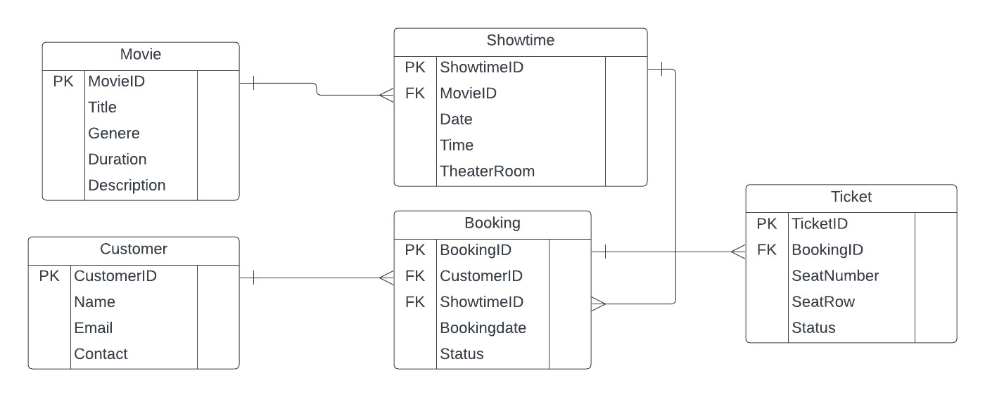

**Business Domain Models:**

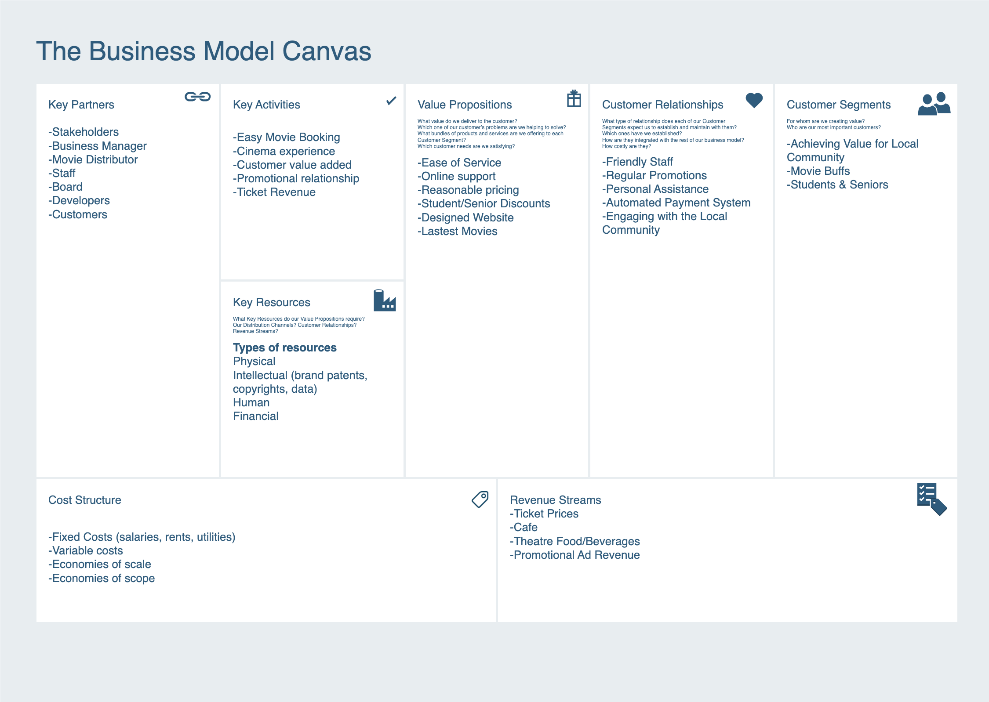

**Verifying Requirements:**

**Prototyping and Mockups:**

* Create prototypes or mockups of the user interface to visually demonstrate how the system will look and function. This allows stakeholders to interact with a tangible representation of the system and provide feedback.

**Cross-Validation:**

* Verify that the requirements are consistent with each other and that there are no contradictions or conflicts among different requirements.

**Functional Testing:**

* Conduct functional testing to validate that each requirement is implemented correctly. Test cases should cover different scenarios for making bookings, selecting seats, generating tickets, and processing payments.

**Non-Functional Testing:**

* Perform non-functional testing to validate aspects such as user interface design (user-friendliness, color scheme), web security features, and performance

**Documentation Review:**

* Review the documentation to ensure that all requirements are properly documented, including any updates or changes made during the development process.

**Analyse non-functional requirements:**

The non-functional requirements for the Tongariro Cinemas project include elements that are essential to the system's success. For simple movie access and reservations, the website must load quickly, have a user-friendly interface, and have straightforward navigation. Constant accessibility is guaranteed by a 99% uptime goal, barring maintenance windows. While a security audit protects data and transactions, scalability must handle peak demand. Development is guided by the principles of user-centered design, and phone booking benefits senior users. Consistent functionality is ensured by flexibility between devices and compatibility with browsers like Chrome and Firefox. Web accessibility guidelines benefit disabled users. Overall, these requirements result in a safe, user-friendly, and easily accessible online booking system that is in line with Tongariro Cinemas' goals.

**Validating Requirements:**

-Website: website is working and functional

-Changes: Any changes to the requirements should be reported.

- Prototyping: any website prototypes must be referred to and checked for its alignment with business goals and requirements.

-Reduce repeatability: do not repeat the same thing on the website.

-Re-useability: The website construction should be easy to read for other developers to follow.

-Maintenace: any website maintenance should not affect the website functionality unless clearly stated on the website

-Simplicity: website should be simple and easy to follow.

-Comprehensiveness: all areas of the business requirements should be covered in detail.

-Agile Requirements: Principles of agile development are considered and followed throughout development.

**Defining Scope and constraints:**

The new cinema system should focus upon:

-Improved efficiency of business processes in an online system for booking.

-Retain data storage and access for the database of customer data and booking.

-A complex cinema website with booking and payment handling.

-Time constraints: The new cinema system is required as soon as possible.

Budget Limit: $30,00

**2.  Solution Design (Zane)**

Figma board:

https://www.figma.com/file/ZSYoTwZkUl9KGQYRqws7pI/movie-theatre-page-ting?type=design&node-id=0%3A1&mode=design&t=Hfv7PG7Bqce2xQ74-1

1. Solution Design based on the findings from requirements analysis report and the business needs of the client.

2. Site Navigation/ site map shows all the pages / views needed.

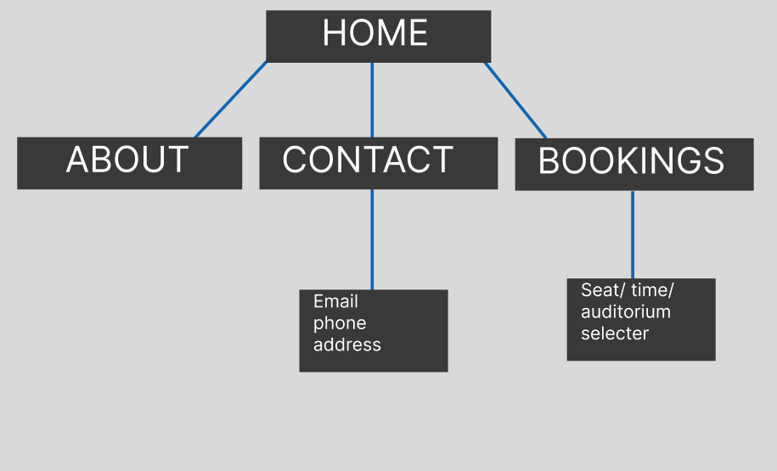

3.  Wireframes (hold ctrl and scroll to zoom in)

DESKTOP HOME PAGE

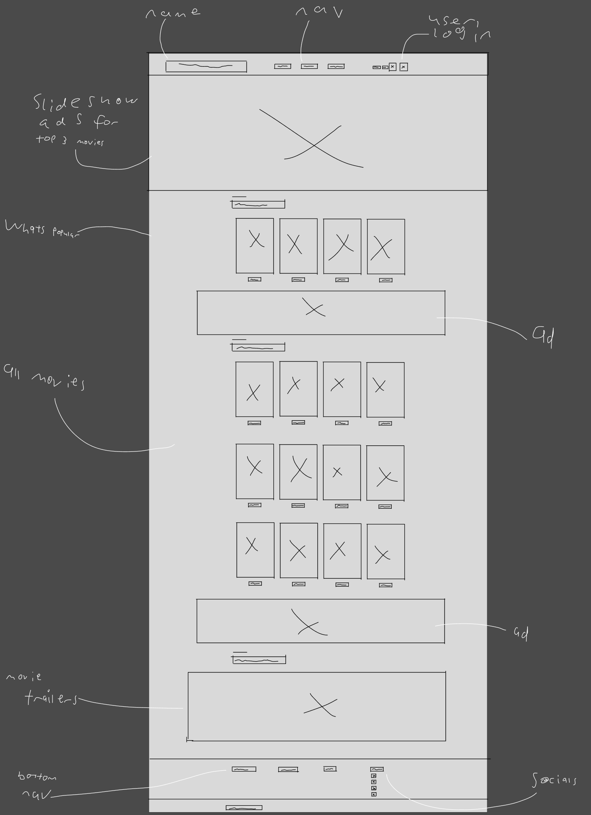

DESKTOP ABOUT PAGE

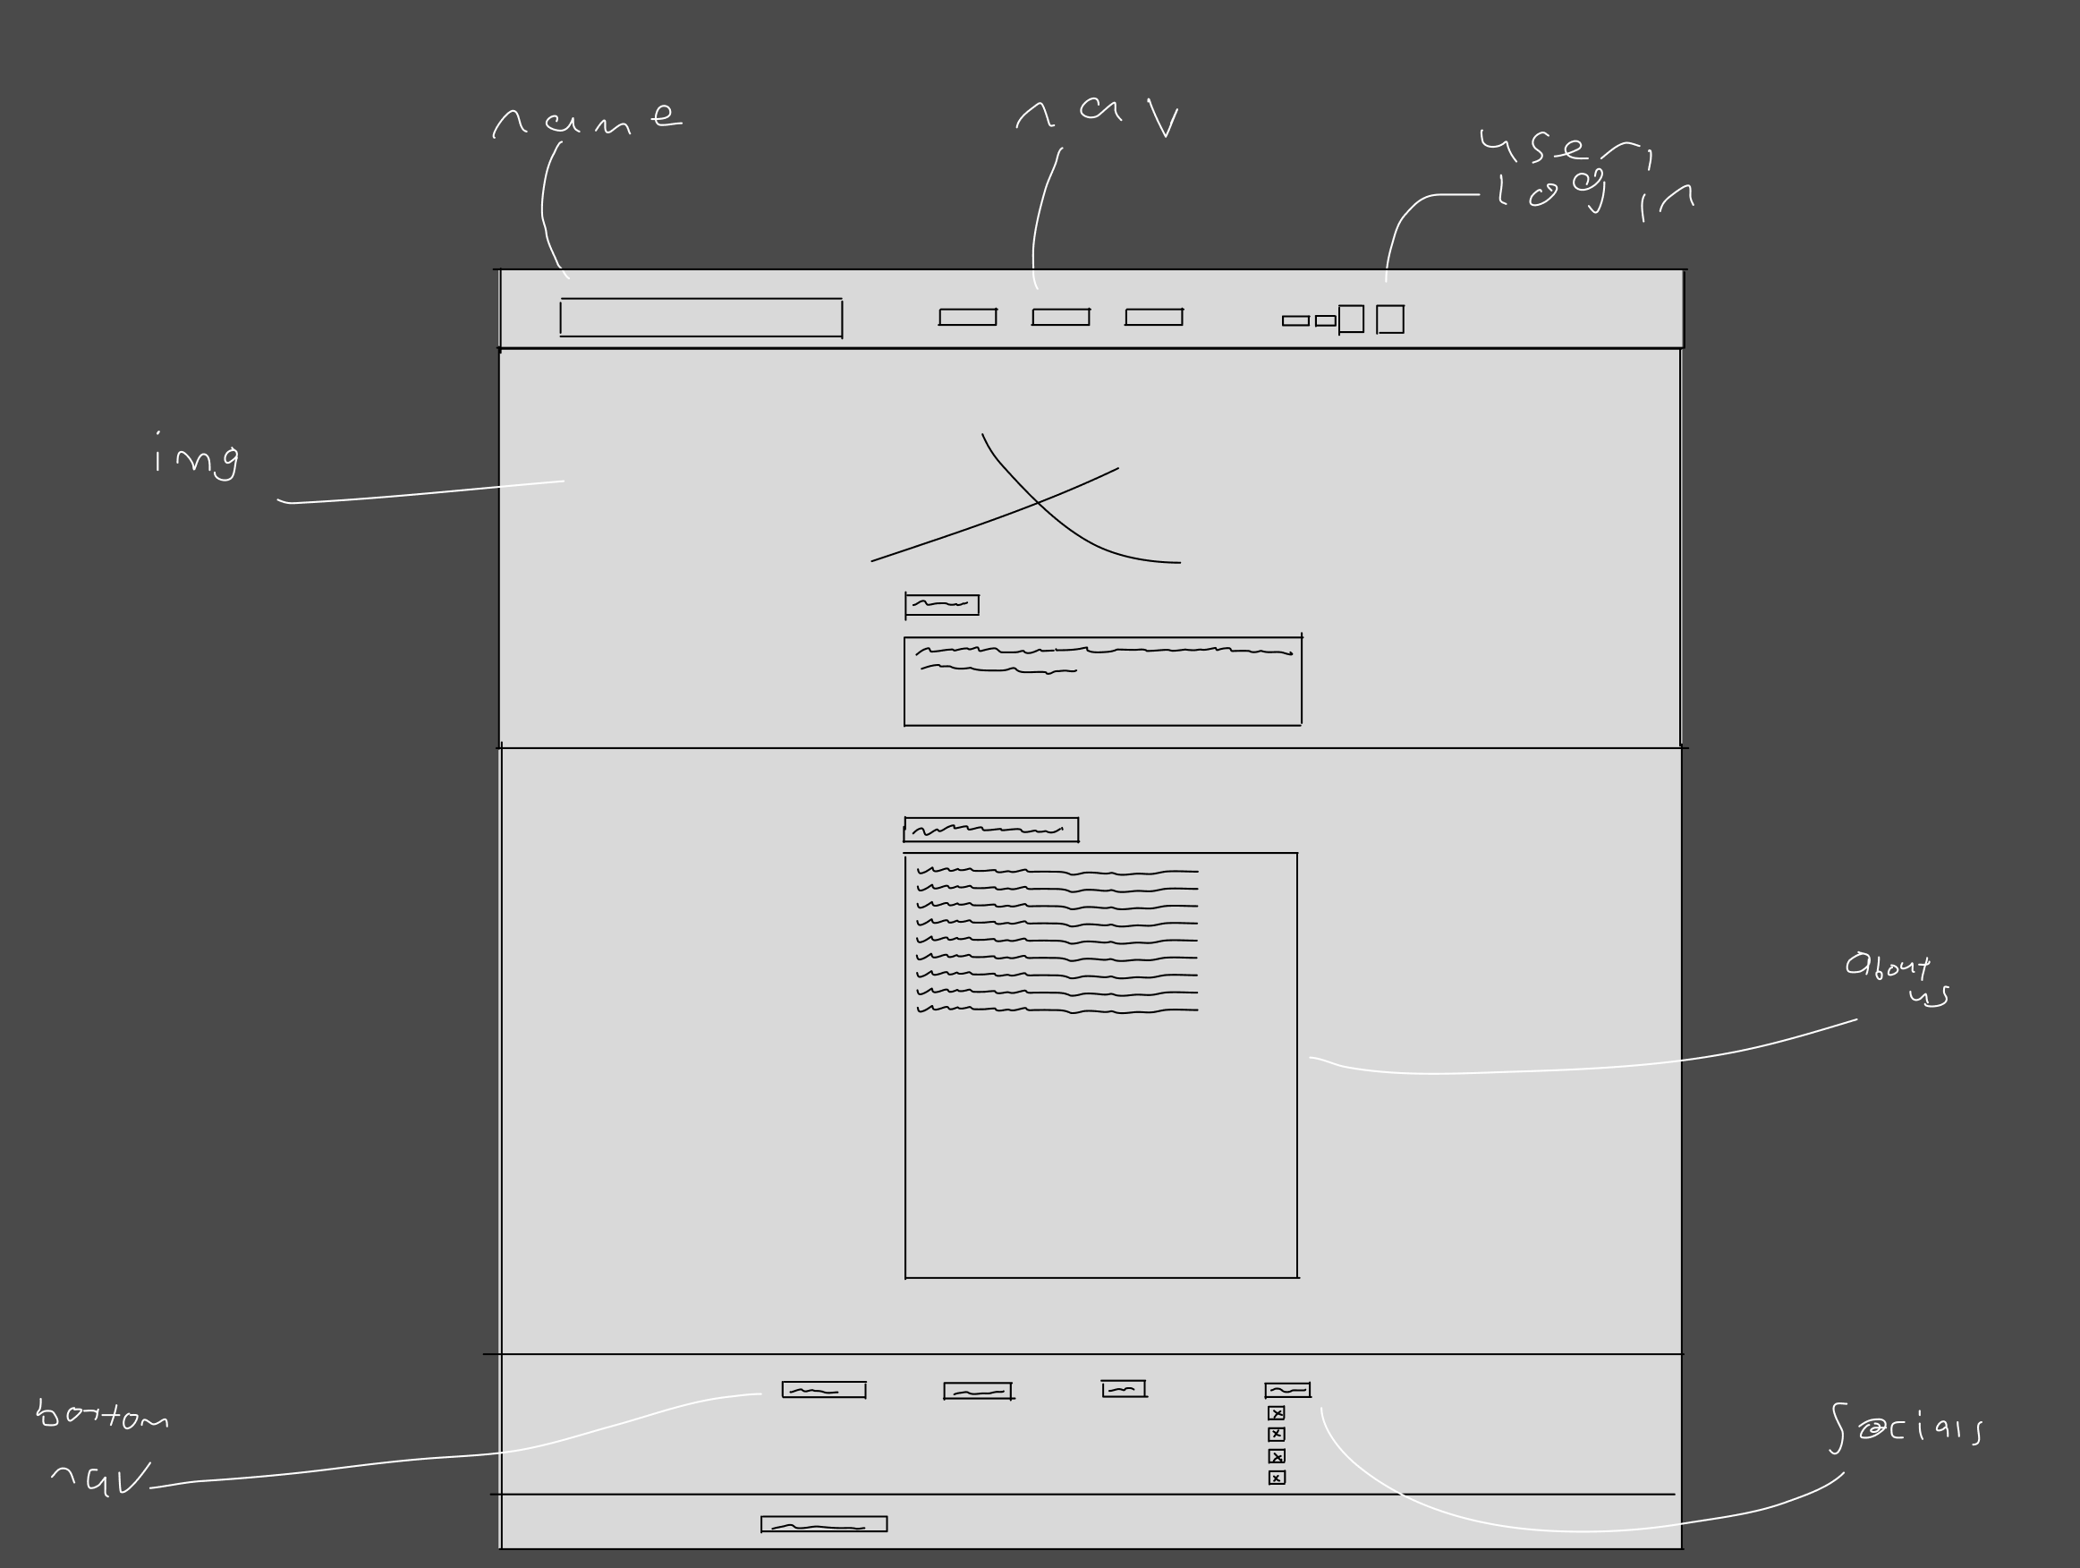

DESKTOP CONTACT PAGE

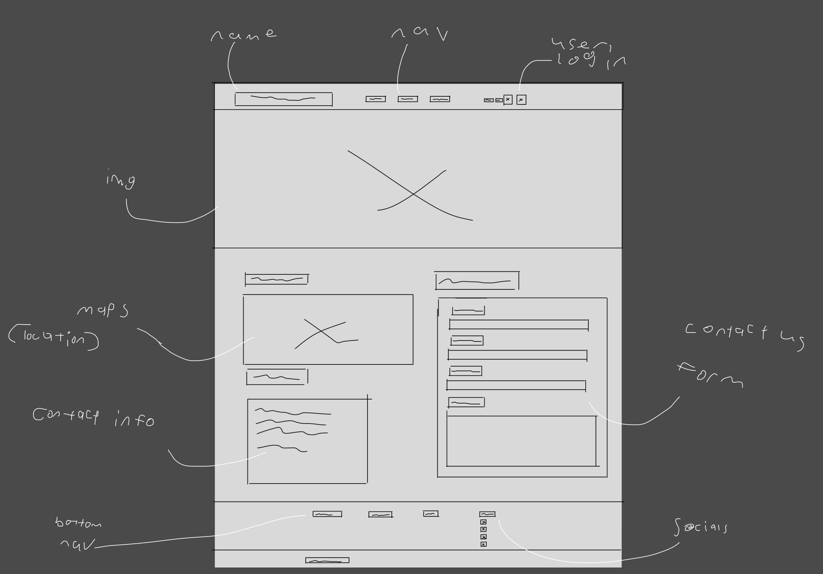

DESKTOP BOOKING PAGE

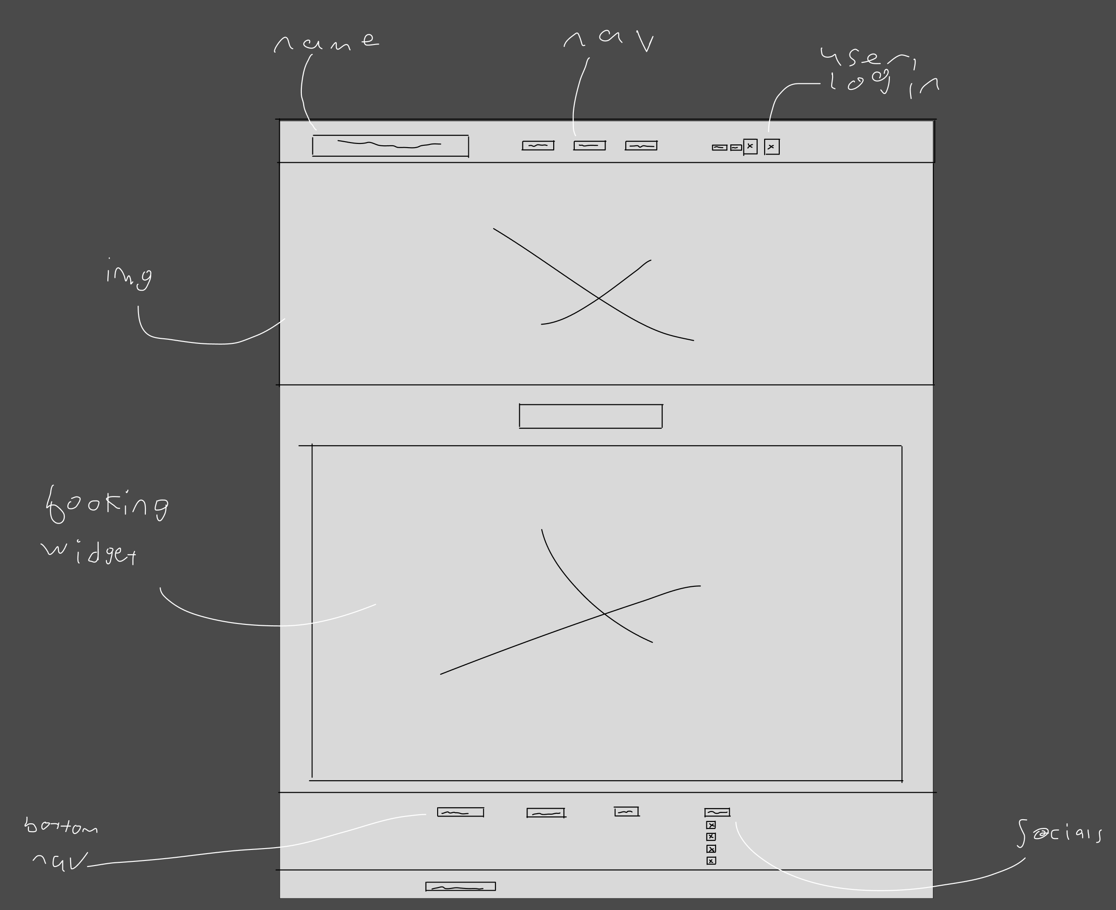

TABLET HOME PAGE

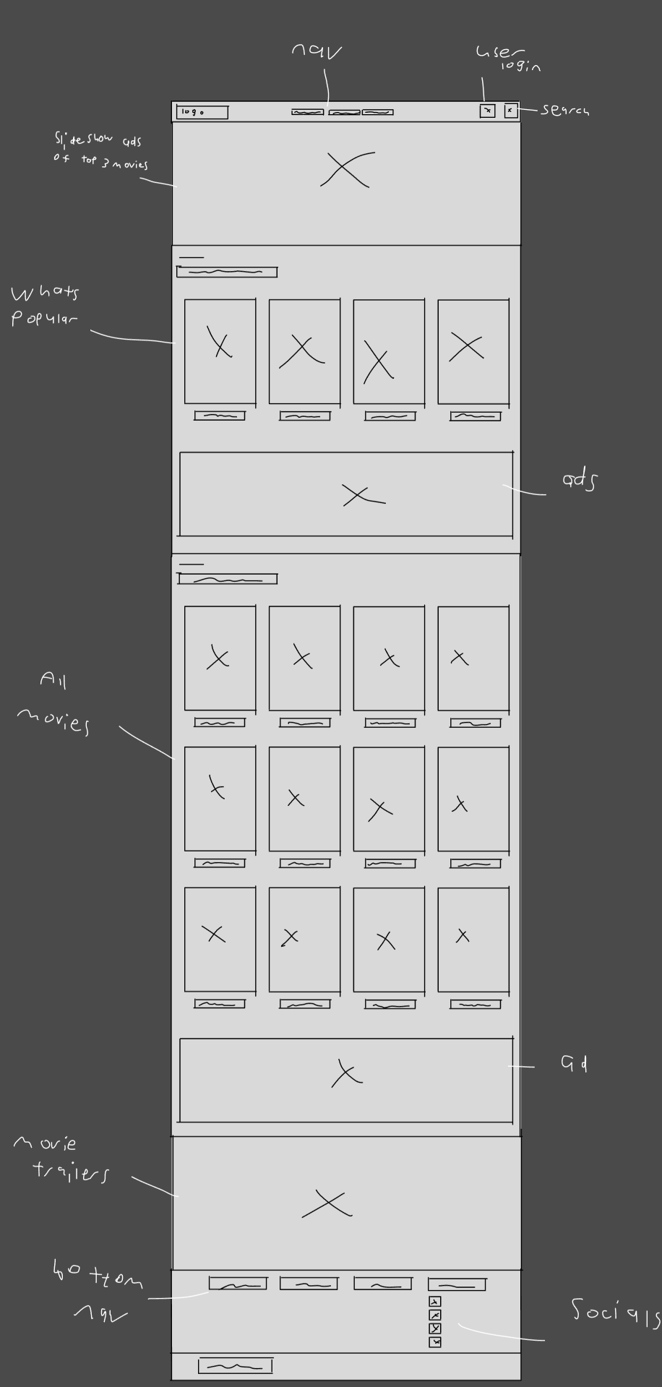

TABLET ABOUT PAGE

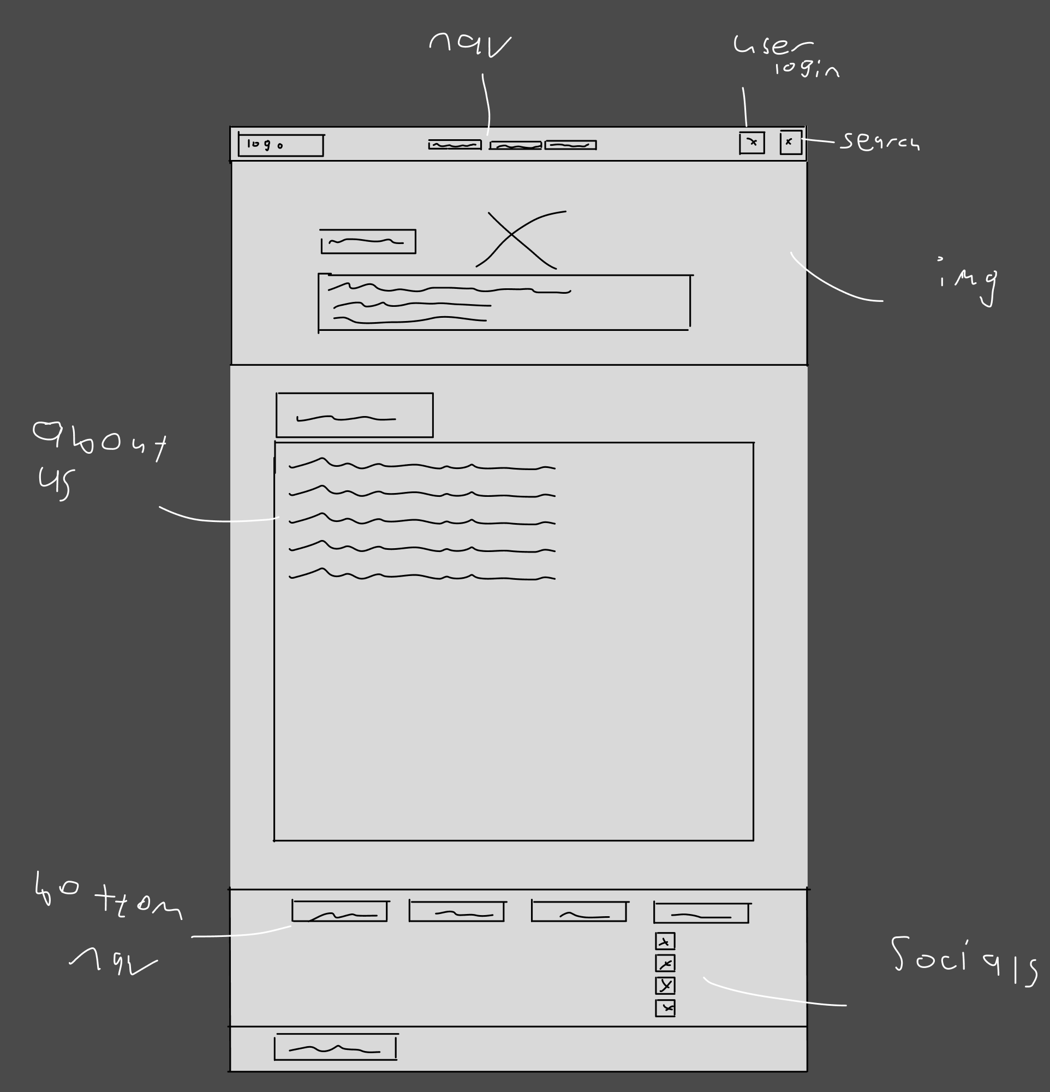

TABLET CONTACT PAGE

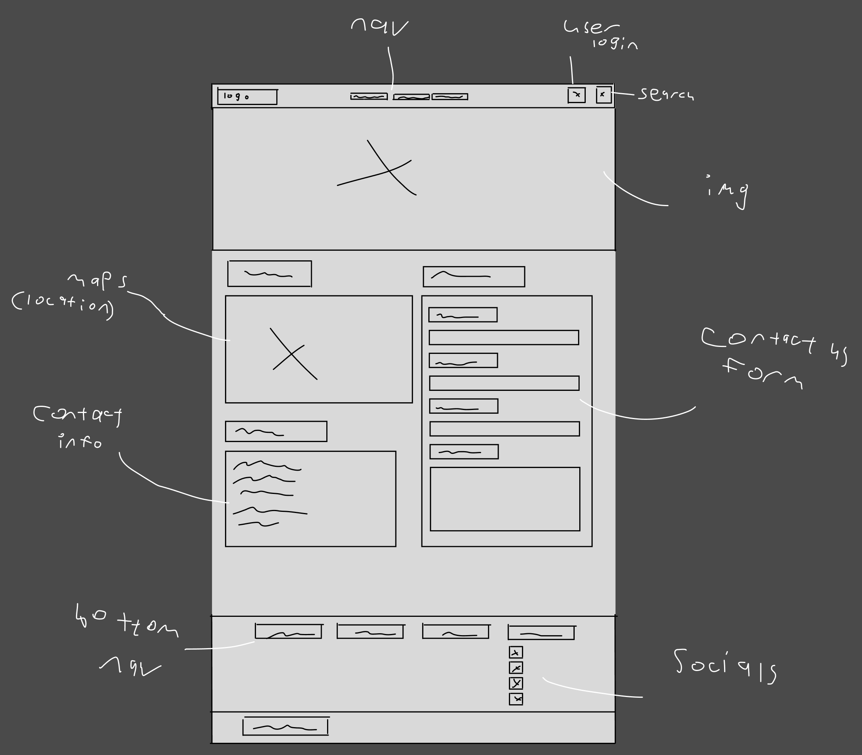

TABLET BOOKING PAGE

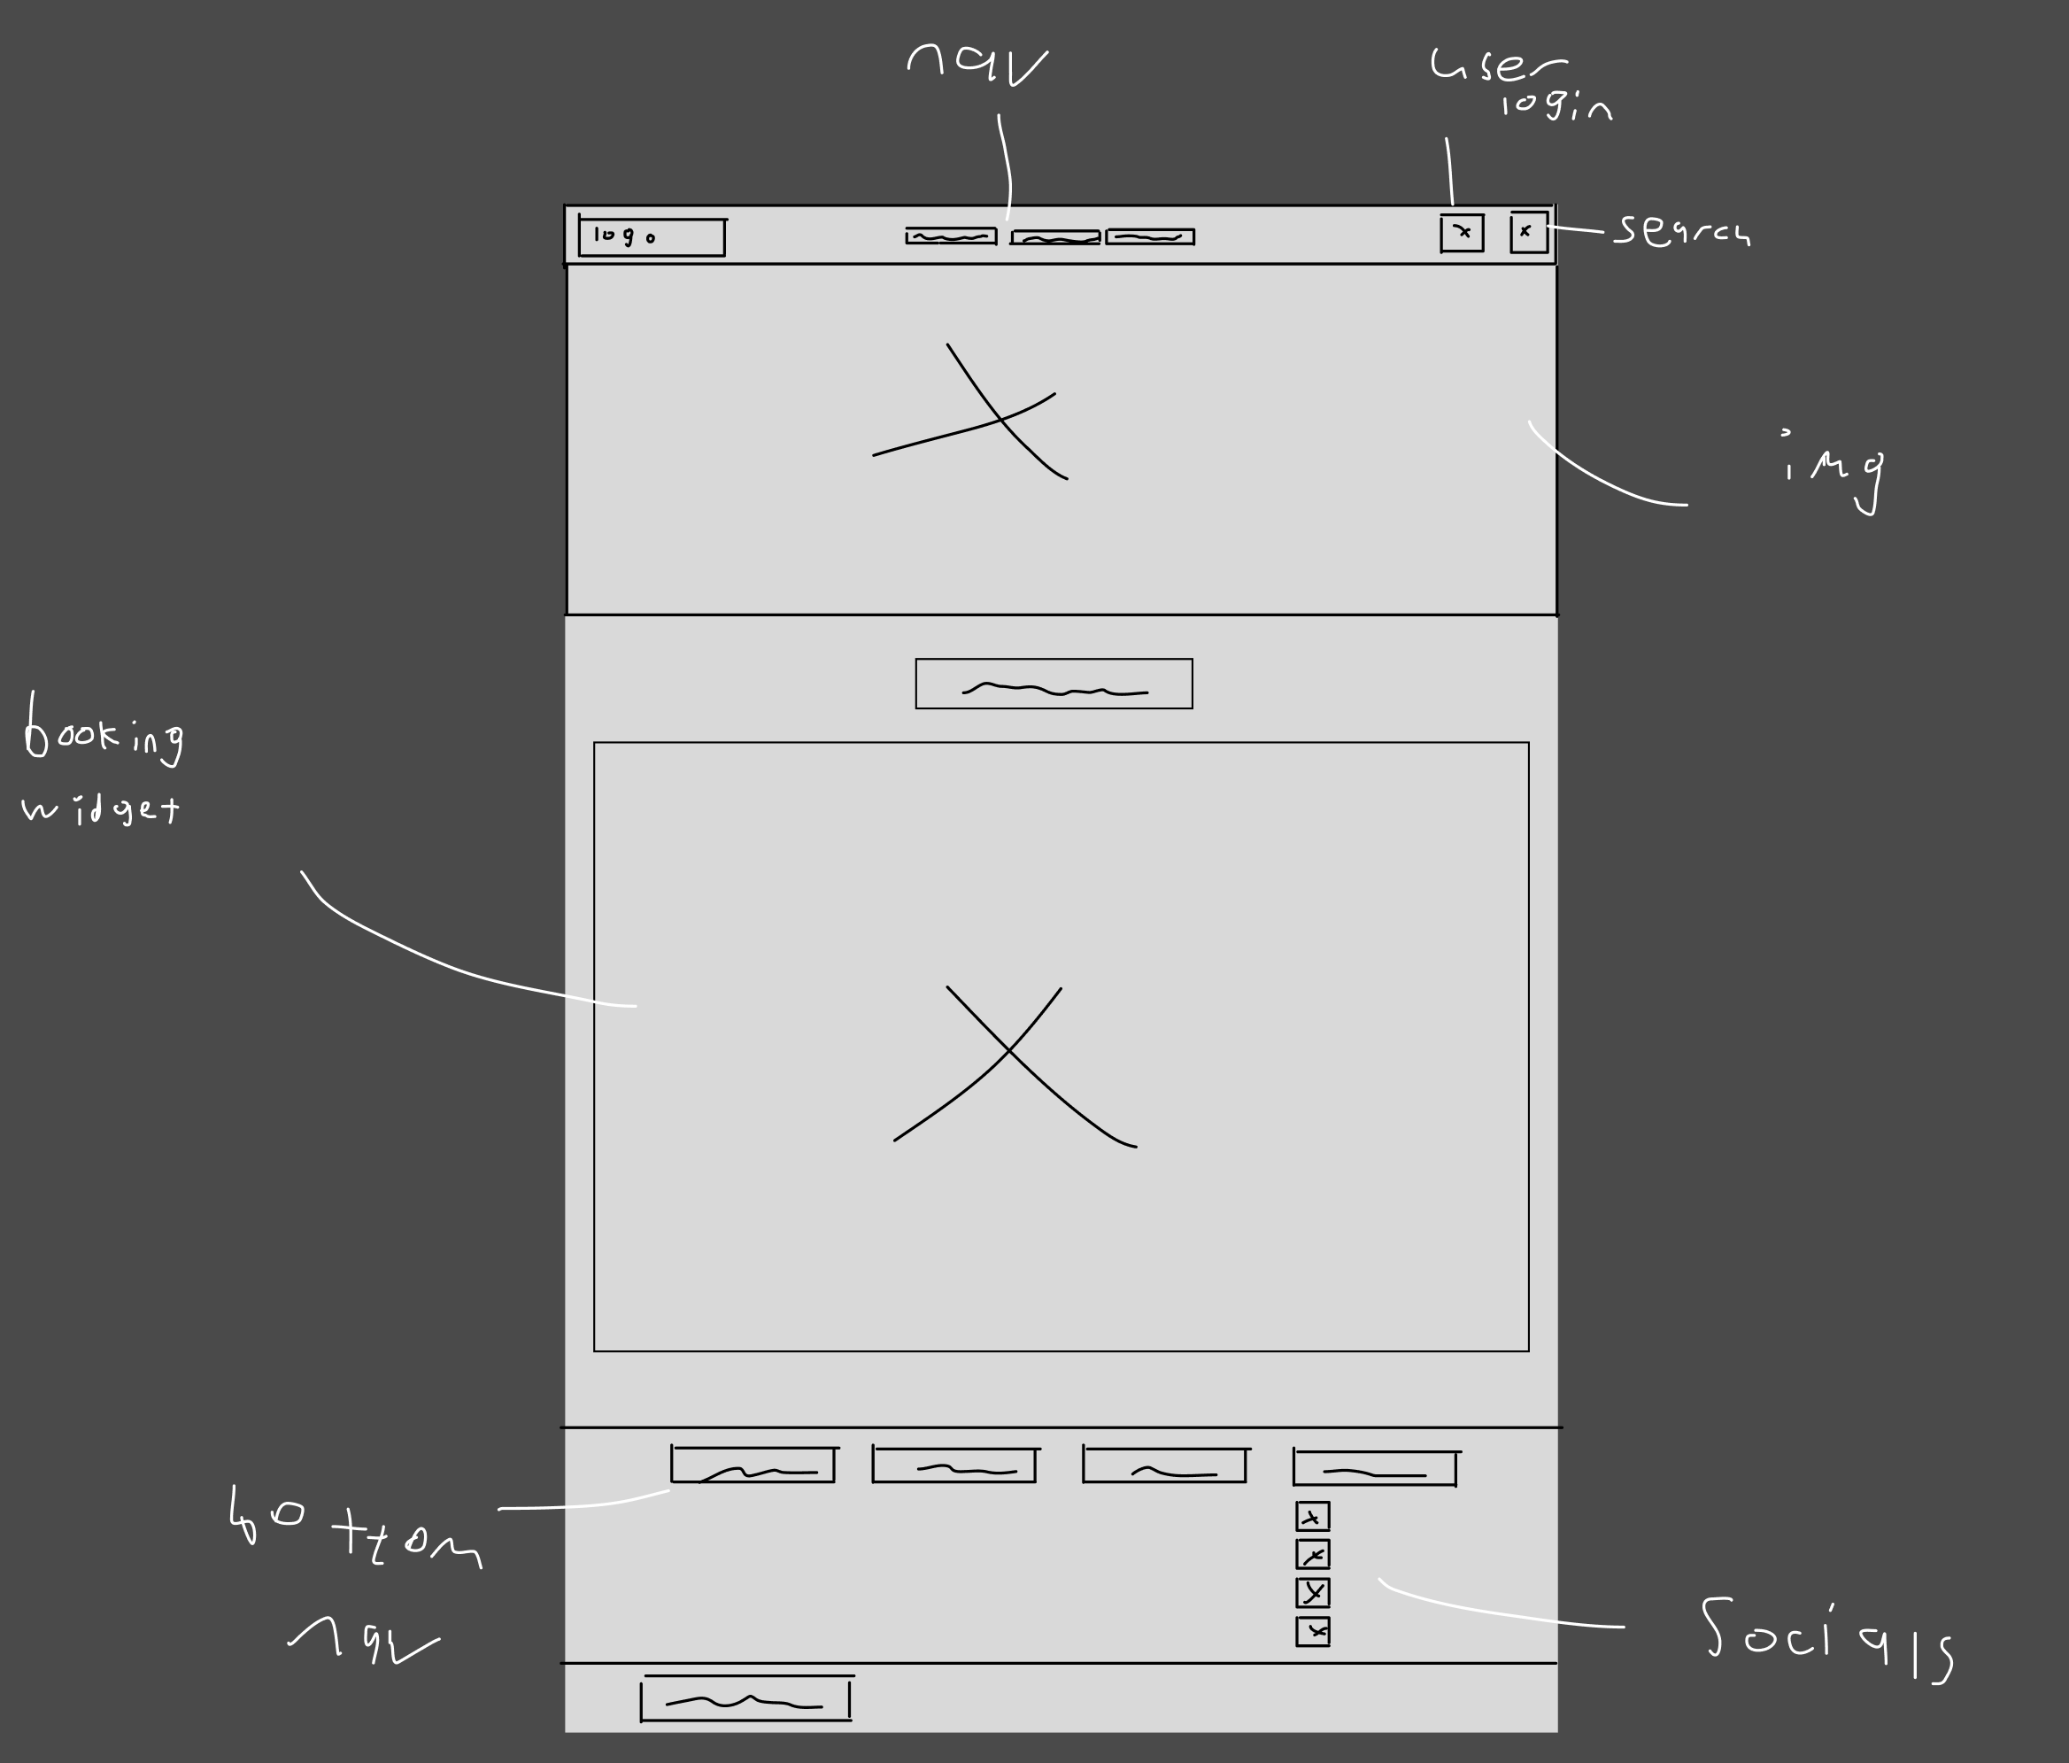

MOBILE HOME PAGE

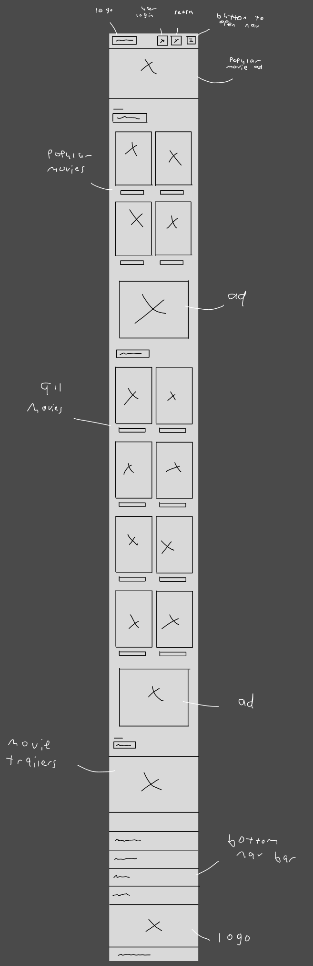

MOBILE ABOUT PAGE

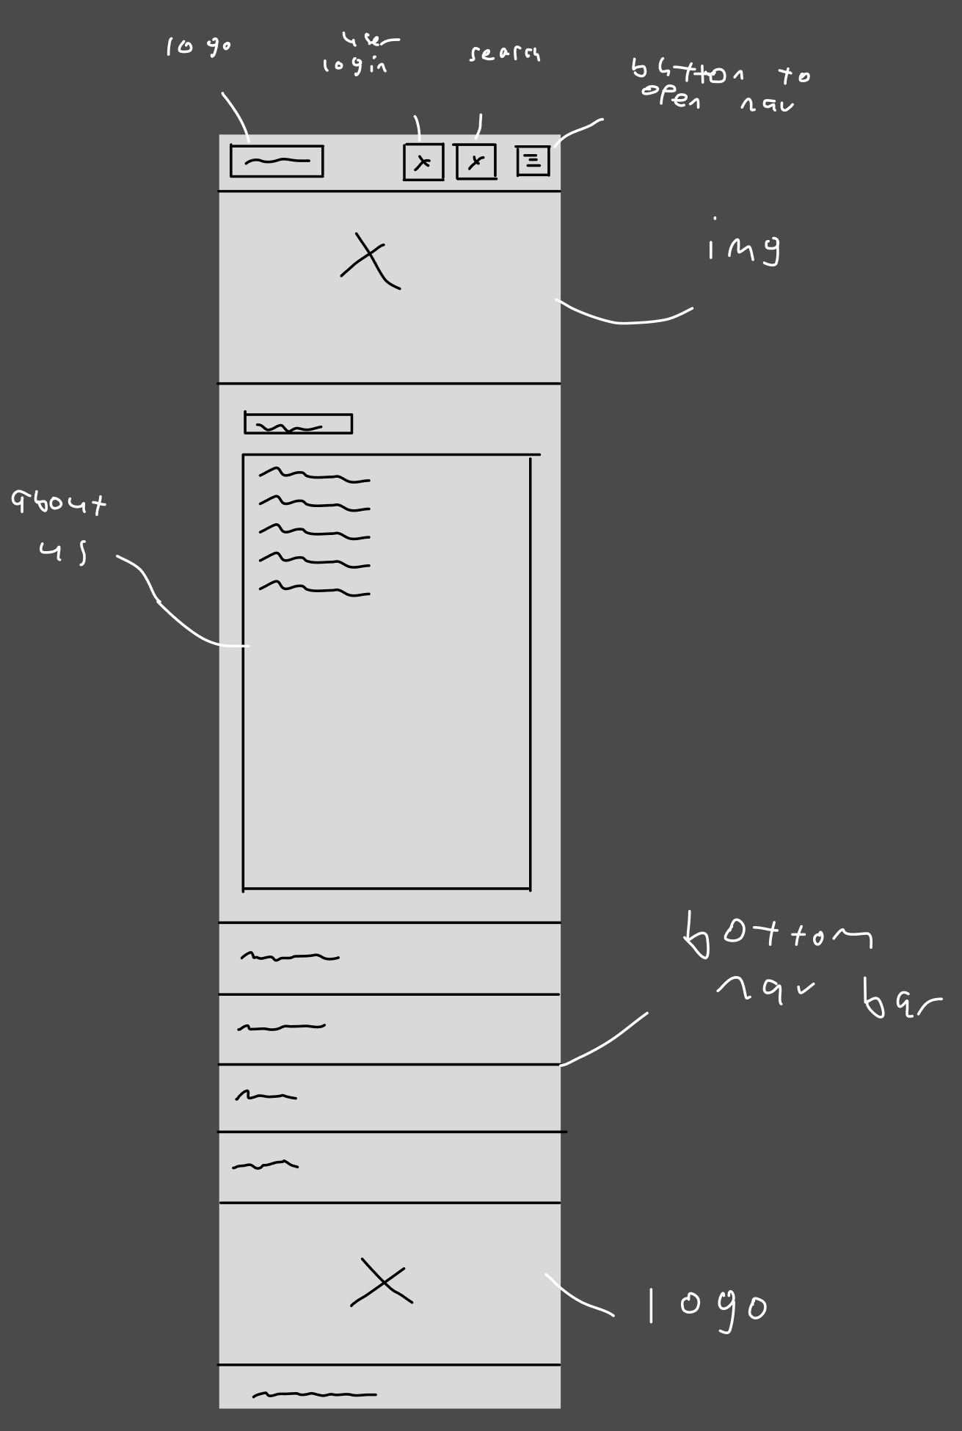

MOBILE CONTACT PAGE

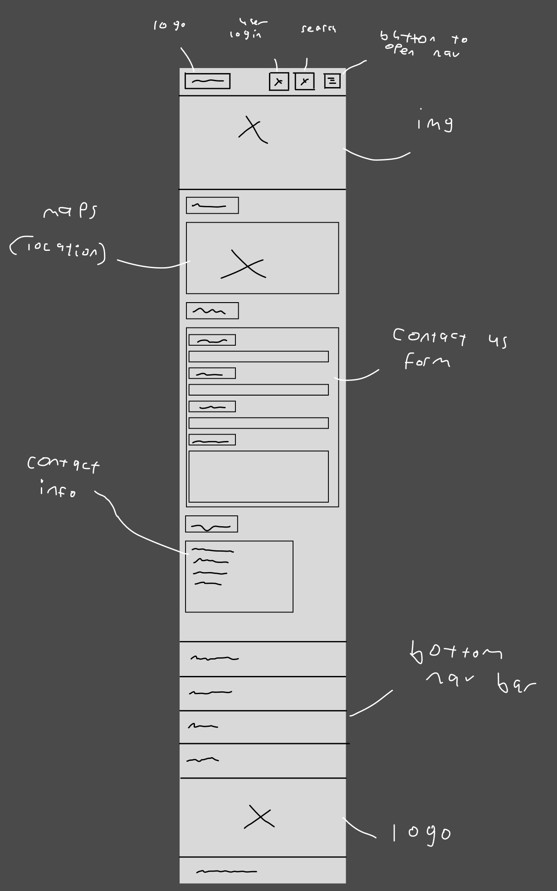

MOBILE BOOKING PAGE

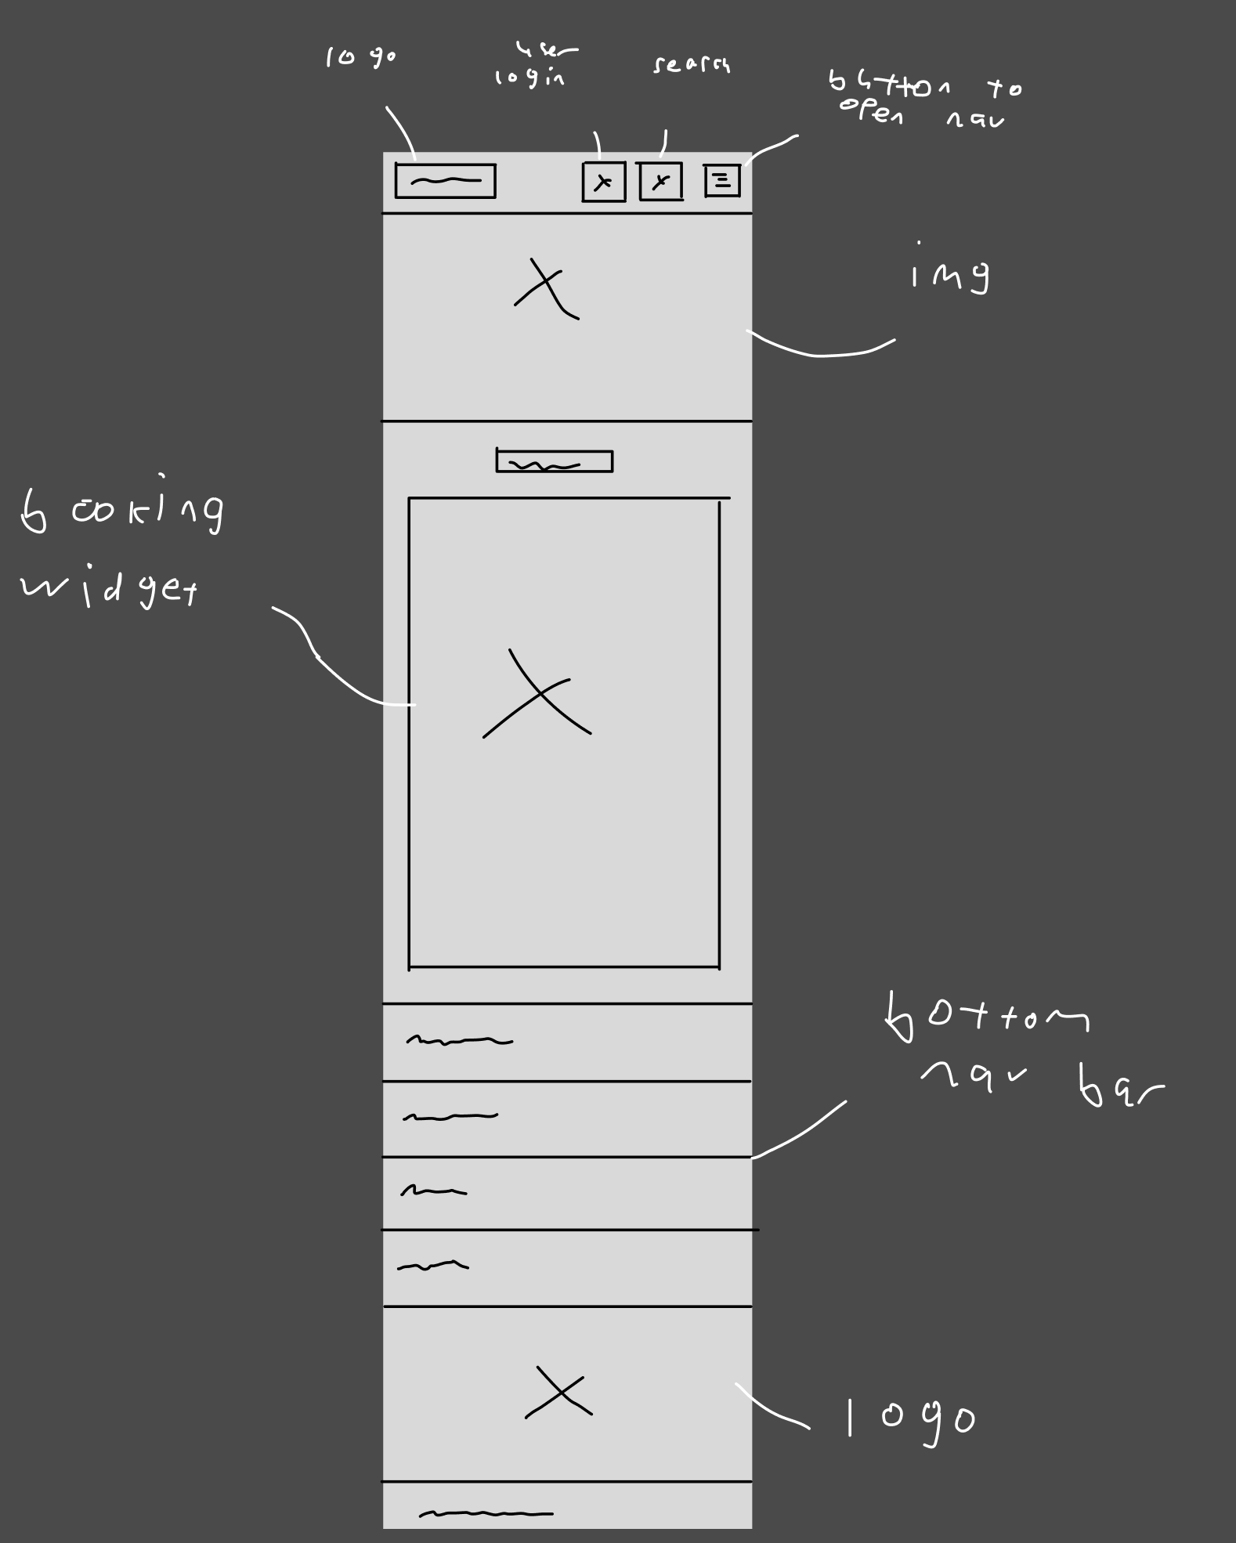

5. Mock-up provided for the core page.

DESKTOP HOME PAGE MOCKUP:

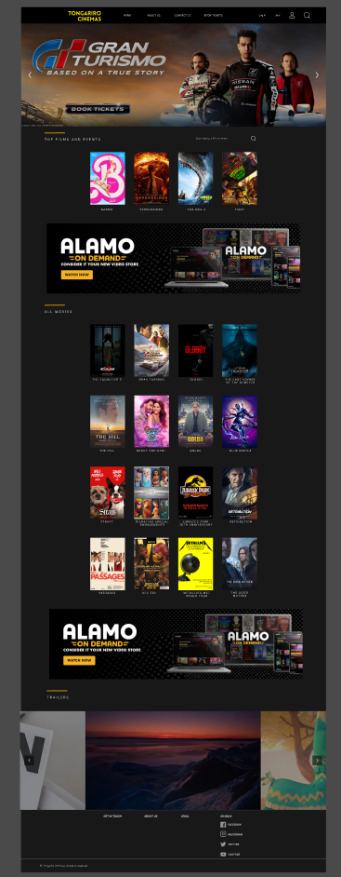

6. Navigation - Primary navigation is easy to find and understand. User can easily navigate to desired page.

7. Efficient and Functional - User can efficiently perform the core task in the user story. User input fields well-designed.

8. Consistent - The site shows a consistent style between pages

9. Creative Design - follows natural eye flow, balanced

proportions, use of contrast improves readability.

10. Spacing - spacing between elements highlights separation of content.

11. Colours & Fonts – Harmonious colour palette, consistent font combination.

FONTS AND COLOR PALLETE

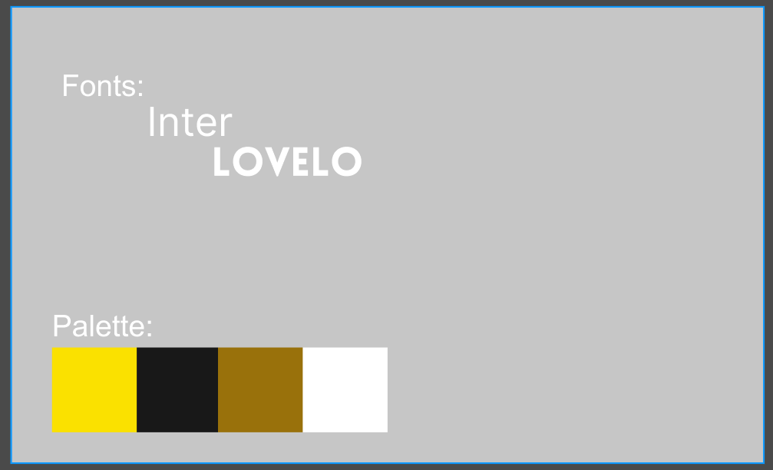

**Team Member Evaluations (Average) - Taylor, Zane, Isaac, Jeffrey**